PROJECT REPORT

Title: Impact of Multi Player & Single Player

Gaming on Academics.

Prepared by:

Saurabh Singh 92

Sean Rodriguez 95

Submitted To: Prof. Sanchayita Banerjee



St. Francis Institute of Management and Research

Mt. Poinsur S. V. P. Road, Boriwali (W) Mumbai

TABLE OF CONTENTS

LIST OF TABLE AND ILLUSTRATION 3

INTRODUCTION 4

BACKGROUND 4

LITERATURE REVIEW 5

NEED FOR STUDY 6

OBJECTIVE 6

RESEARCH METHODOLOGY 7

DATA ANALYSIS WITH GRAPHS 8

HYPOTHESIS TESTING 9

STATEMENT OF FINDING 13

LIMITATIONS 13

RECOMMENDATION 13

REFERENCES 14

APPENDICES 15

# LIST OF TABLE AND ILLUSTRATION

Graph 1: Time records of Multiplayer Gamers of average everyday play…………………… 8

Graph 2: Time records of Single player Gamers of average everyday play…………………..8

Graph 3: Academics performance of Single player vs Multiplayer Gamers………………….9

Table 1: Independent T Test for dependence of timings on time of gamers…………………10

Table 2: Independent T Test for dependence of academic performance on time of gamers...11

Graph 4: Ratio of Single player vs Multiplayer Gamers……………………………………..12

# INTRODUCTION

A video game is an electronic game that can be played on a computing device, such as a personal computer, gaming console or mobile phone. Depending on the platform, video games can be subcategorized into computer games and console games. In recent years however, the emergence of social networks, smartphones and tablets introduced new categories such as mobile and social games. Based on the interaction video games can be classified as Single player video games and multiplayer video games. Video games have come a long way since the first games emerged in the 1970s. Today’s video games offer photorealistic graphics and simulate reality to a degree which is astonishing in many cases. Video games are a billion-dollar business and have been for many years. In 2016, the video game market in the United States was valued at 17.68 billion U.S. dollars. That same year U.S. consumers were said to spend roughly double the amount on gaming content, hardware and accessories. What is important that the effect it leaves on individual’s behaviour and performance? However there is a notion of video games negatively impacting academic performance of the students. The research studies the extent of impact of single player vs online multiplayer video games on the academics performance of the students. Fun and mental agility are among the main reasons cited by the gamers as to why they choose this pastime.

# BACKGROUND

Video games are a popular extracurricular activity for students at all levels of study. They are an important part of a student's social life and are an enjoyable activity whether one is playing games alone or in a group. There has been a great deal of controversy over the effect that video games have on student's grades. Some claim that video games have a negative impact on students grades while others claim that playing video games has no effect on student's grades, no matter how frequently they play video games. However; neither of these arguments is completely accurate as whether or not playing video games affects your grades is influenced by other factors such as time and frequency and category of game play. It can be hypothesized that spending more than 10 hours per week playing video games can have a negative effect on student academic performance. However; playing less than ten hours per week will have little if any effect on academic performance cannot be said true as other interaction and factors can come into play as of hindering the performance while influencing in a different way.

# LITERATURE REVIEW

Today's world is one that is largely composed of technology. In a relatively short span of time we have been immersed in a world of high-definition television, Facebook, YouTube, internet radio, "green" cars, outrageous thrill rides, 3-D technology, etc. But no area of technology has become as prominent as that of video gaming. According to Anand (2007), the penetration of video games into the United States alone is huge, with at least 90% of homes having children that have played (rented or owned) video games. This is a record level that continues to increase. 55% of console players and 66% of online players are over 18. The college demographic seems to be the major group of gamers simply because they have a lack of parental supervision and they have more flexible schedules, allowing for more play time (Anand, 2007). There are also others that have found decreased academic performance in relation to involvement in playing video games. Anderson and Dill (2007) studied video games and aggression and suggested that not only does gaming have an impact on performance directly, but it also triggers a higher level of aggression, which is often linked to problems in school and decreased academic performance. Wack and Tantleff-Dunn (2009) also found a negative correlation, although the relationship between GPA and academic performance in their study was not significant. Jackson et al (2008) found that time spent playing games was a negative predictor of academic performance and that those who played video games more often had poorer grades than those who played less. Computers have been shown to have various effects on student's academic performances. Jackson, von Eye, Witt, Zhao and Fitzgerald argue that whether or not video games influence a student's academic performance is based on a student's gender, race, ethnicity, parent's income, as well as initial academic performance and amount of time spent playing video games. Anand hypothesizes that video games have a negative impact on academic performance. In a content analysis of grades and Scholastic Aptitude Tests (SAT) scores and surveys from 276 college students, Anand found that college students who played video games for more than a few hours a week had overall lower grades and SAT scores than students who reported that they spent a limited amount of time playing video games. Males were more likely to experience a drop in grades due to frequent use of video games whereas, females showed no noticeable effects. Skoric, Lay-Ching-Teo and Lijie argue that students with addictive personalities who play video games are more likely to have lower grades than students with non-addictive personalities who play video games. They found that while amount of time spent playing video games or engagement in video game play had no effect on typically developing children, children with addictive personality traits were more likely to have problems with their grades if they played video games because they were more likely to neglect their studies in favour of game play. Finally, Gentle, Lynch, Linder-Ruh and Walsh hypothesize that adolescents who were frequent video game players (more than 10 hours per week) would demonstrate more problems with aggression and hostility and lower grades than student's that were infrequent gamers. Gentle et al. also argued that the effects of frequent video gaming would be more prominent if the video games were violent in nature. In a study of 607 middle and high school student's they found violent video games were more highly correlated with hostile behaviors, aggressive behaviors such as, bullying, and lower grades than infrequent gamers. They found a strong correlation between gender and increased hostility and aggression and lower grades, as male participants were more likely to experience these effects than female gamers.

# NEED FOR STUDY

Many negative notions about gaming has been set in the society regarding its consequences on the academics of the student. In the era of digitalization where access to video games is convenient to a large part of the society where video games have evolved with the support of cheap hardware fitted in handheld devices. Between two categories of games that are single player and online multiplayer games which have a different gameplay and requires different set of skills and is received differently, the research will study the relation between types of video games the student plays to the academics performance of the student. The Research also studies the types of video games the student plays versus the time they invest in playing the game.

# OBJECTIVE

1. To study the relationship between types of games (single/online multiplayer) a student plays on the time spends playing.
2. To study the comparison of effect of single player game and multiplayer games on academic performance.
3. To determine whether single player or online multiplayer games is more preferred by gamers.

# RESEARCH METHODOLOGY

Research Design:

The research is a descriptive research using Quantitative Technique.

Data collection

The data collection is done through Primary data using a structured Questionnaire. The secondary data is produced from research articles, magazines and journals.

Sample size:

142 Respondents.

Sampling technique:

Multistage sampling: Snowball sampling & Judgement sampling

Data analysis:

Using pie charts.

HYPOTHESIS

1. (H0)= There is no relationship between type of game a student plays and the amount of time he sends playing.

(H1)= There is a relationship between type of game and time spent playing.

1. (H0)= There is no relationship between type of game a student plays and his academic performance.

(H1)= There is a relationship between type of game and academic performance.

RESEARCH INSTRUMENTS

1. Independent T test to find the relationship between the types of game gamer’s plays and the time spent on the game.
2. Independent T test to find the relationship between types of game gamer’s play and the academic performance of the student.

# DATA ANALYSIS WITH GRAPHS

How long in a day do you spend playing online multiplayer of video game on an average?

For Multiplayer Gamers (46 Responses)

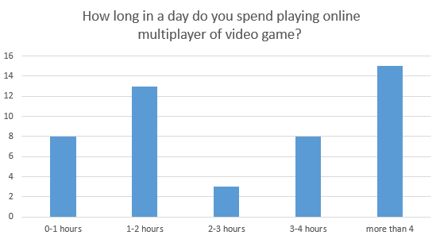

Graph 1: Time records of Multiplayer Gamers of average everyday play

Interpretation: It is observed that Online Multiplayer gamers tend to spend more time on a daily average in playing games as compared to single player gamers.

How long in a day do you spend playing Single player of video game on an average?

For Single Player Gamers (96 Responses)

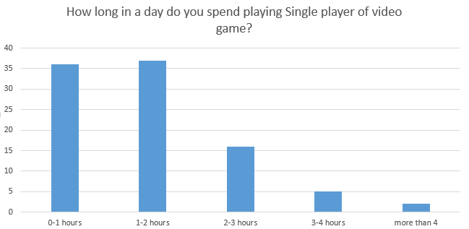

Graph 2: Time records of Single player Gamers of average everyday play

Interpretation: It is observed that Single player gamers tend to less more time on a daily average in playing games.as compared to multiplayer gamers.

What was your last semesters score?( in % )

142 Responses

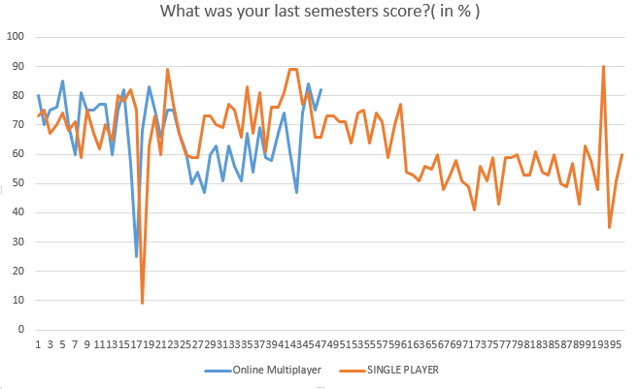

Graph 3: Academics performance of Single player vs Multiplayer Gamers.

Interpretation: It is observed that Single player gamers have an average of average of 64.51%, while multiplayer gamers have an average of 66.72%.

# HYPOTHESIS TESTING

TEST 1: TO TEST THE RELATONSHIP BETWEEN THE TYPE OF GAME A STUDENT PLAYS AND THE AMOUNT OF TIME HE SPENDS PLAYING.

• NULL HYPOTHESIS (H0): There is no relationship between type of game a student plays and the amount of time he sends playing.

• ALTERNATE HYPOTHESIS (H1): There is a relationship between type of game and time spent playing

Confidence level = 95%

Significance level = 0.05

We conduct an independent t- test as we are studying 2 different groups that is people who play single player games and people who play online multiplayer games. It is a two tailed test since us not trying to find out if single player results are better or worse than multiplayer results. The number of respondents who choose single player and online multiplayer along with their time spent playing has been derived from the questionnaire. We have 47 respondents in the first group (single player) and 96 respondents in the 2nd group (online multiplayer)

The analysis of results s shown below after the independent t test is conducted.

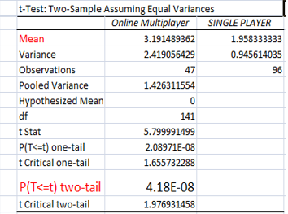

Table 1: Independent T Test for dependence of timings on time of gamers.

Therefore we obtain P value as 4.18E, Standard Deviation as 1.5 and 1 respectively and mean of 3.2 and 1.95 respectively of groups one and two.

Since P value < 0.05, we reject the null hypothesis and accept the alternate hypothesis which says there is a relationship between the type of game and amount spent playing.

Also the mean time spent of those who played online multiplayer games is 3.2 (3 hours 10 mins) hours and that of single player games s 1.95 hours (i.e. 2 hours approx.).Therefore we can conclude that online multiplayer games are more addictive and people spend more time playing them compared to single player games.

**TEST 2**: TO TEST THE RELATONSHIP BETWEEN THE TYPE OF GAME A STUDENT PLAYS AND HIS ACADEMIC PERFORMANCE

* NULL HYPOTHESIS (H0): There is no relationship between type of game a student plays and his academic performance.
* ALTERNATE HYPOTHESIS (H1): There is a relationship between type of game and academic performance.

Confidence level = 95%

Significance level = 0.05

We conduct an independent t- test as we are studying 2 different groups that is people who play single player games and people who play online multiplayer games. It is a two tailed test since us not trying to find out if single player results are better or worse than multiplayer results. The number of respondents who choose single player and online multiplayer along with their time spent playing has been derived from the questionnaire. We have 47 respondents in the first group (single player) and 96 respondents in the 2nd group (online multiplayer)

After conducting the t test we get the following results as shown below

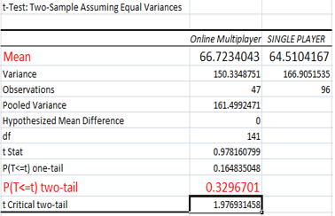

Table 2: Independent T Test for dependence of academic performance on time of gamers.

Therefore we obtain P value as 0.329, Standard Deviation as 12.5 and 12.92 respectively and mean of 66 and 64 respectively of groups one (single) and two (multiplayer).

Since P value > 0.05, we accept the null hypothesis which says there is no relationship between the type of game and amount spent playing.

The students who play online multiplayer games have a mean academic score of 66% and those who play single player have a mean score of 64%. Therefore we can conclude that type of game doesn’t have any significant impact on academic performance.

PREFERENCE OF GAMERS:

Survey analysis:

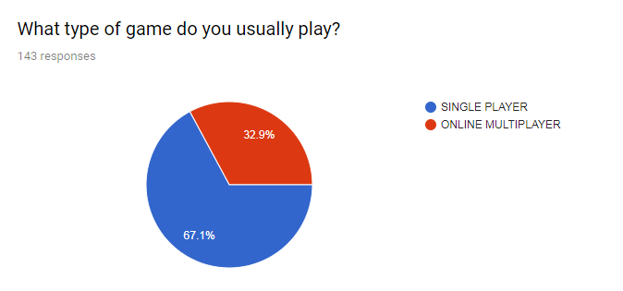

Graph 4: Ratio of Single player vs Multiplayer Gamers.

Therefore from survey results we can conclude that more numbers of gamers prefer single player games –

* 67% single player
* 32.9 % online multiplayer

Hence game developers must focus on developing more single player games as the profit would be more.

# STATEMENT OF FINDING

* Online multiplayer games are addictive and are played for longer hours. This is because you normally play online multiplayer games with your friends from your city and around the globe. So it could be quite fun and immersive.
* Even though online multiplayer games are usually played for longer hours, only 27 % of them have low marks (below 60). This is a much unexpected result as the people who usually play online multiplayer games tend to play for longer hours. Despite this fact 77% of online multiplayer gamers (in our survey) have managed to score 1st class or above. The reason could be that these gamers had made a strong exam schedule to study and resisted the temptation to play.
* Single player games are played for lesser hours, yet 26% of students scored less marks (below 60) .This could be because other than gaming, there are also many other factors which could distract a student from studying. For example social media, Netflix, watching movies, sports etc.
* People prefer to play single player games more. This could be because of top notch graphics in single player games combined with great story telling.

# LIMITATIONS

* Small sample size: We have a small sample size of 141 respondent’s .The results one sample shows could be different from another set of sample. The larger the sample, the more reliable your data gets. You cannot expect a sample to behave exactly like the whole population. Therefore we might get difference in results
* Unequal respondents: We have 47 respondents who choose single player game and 96 who choose online multiplayer game.
* Unrealistic responses: Some respondents did not seem serious about filling the survey and put inappropriate responses which could cause disruption of results.

# RECOMMENDATION

Game developers must focus on developing more single player games as the profit would be more.

# REFERENCES

https://www.washingtonpost.com/national/health-science/the-effect-of-video-games-on-kids-behavior-achievement/2015/04/06/0781f084-d96f-11e4-8103-fa84725dbf9d_story.html?noredirect=on&utm_term=.a29544c90892

https://www.researchgate.net/publication/223971083_Effect_of_Playing_Violent_Video_Games_Cooperatively_or_Competitively_on_Subsequent_Cooperative_Behavior

https://en.wikipedia.org/wiki/Video_game

https://www.statista.com/topics/868/video-games/

https://scholar.utc.edu/cgi/viewcontent.cgi?article=1197&context=mps

https://www.classcraft.com/blog/features/video-games-and-students-academic-performance/

# APPENDICES

1. Current Education? *

(Radio Button)

SCHOOL

JUNIOR COLLEGE

DEGREE COLLEGE

POST GRADUATION

Other:

2. Do you play video games frequently? *

(Radio Button)

YES

NO

3. What type of game do you usually play? *

(Radio Button)

SINGLE PLAYER

ONLINE MULTIPLAYER

4. How long in a day do you spend playing that type (single player/online multiplayer) of?

Video game? *

(Radio Button)

0-1 hours

1-2 hours

2-3 hours

3-4 hours

More than 4

5. What was your last semesters score? (In %)

(Text Box)

6. Are you involved in any other hobby/activity?

Apart from gaming? If yes please specify the

Activity/ hobby.

(Text Box)